
Jolly Rodgers Preschool Newsletter June 2023

THIS MONTH IS ALL ABOUT ‘What we have explored, where we are going’
Our learning through play will continue to progress well throughout our monthly activities. The children will continue to build on new skills daily, please encourage these at home. This month is about what we have explored and where we are going – introducing transport and holiday destinations. We will talk about travelling in cars/ buses/boats etc. to get to our destination/holidays. We will also be celebrating a special day for dads! ☺ We will also be discussing our next big move to pre-school or moving into P1!! We will also hopefully have lots of outside play with lots of sun!! It will be the perfect opportunity to discuss being safe in the sun – the importance of always using sun cream and wearing a hat when outside.
THIS MONTH’S SONG’S –
Twinkle twinkle
The wheels on the bus
Row row row your boat
The Daddy song
And many more…



THIS MONTH’S COLOUR – YELLOW sand trays will be filled with sand with sea shells, cars, buses, vehicles and moulds will all be added throughout the month.
Water Trays will change throughout the month, fish, pebbles, boats; these will all be added during the month.

THIS MONTH’S ARTS (we will send home children’s work for you to display)

All art work will include gluing, sticking, colouring, painting and cutting relating to our theme.

We will also be making Father’s Day cards along with a surprise for a special someone this month!

Free play art resources and junk art available throughout each week.

We will also be doing cooking activities this month which will be fairy buns & summer smoothies.



Lower level of loft will be rainbow themed with our light box.
The upper level will be ‘at the airport’ and ‘travel agents’

All children will be encouraged to create their own items for the loft area and create their own artwork.

Tuff tray will be transport & travel.

THIS MONTH’S CIRCLE TIME

Within the classroom we will use “Circle Time” to read stories, poems etc to develop each child’s love of books and language.
We will read books and learn our new songs. Our rhymes & stories will all be theme related and will include the following:

I love my daddy
Transport books
We will also use circle time to discuss:
Days of the week
The colour yellow
Countries we have travelled to on holidays

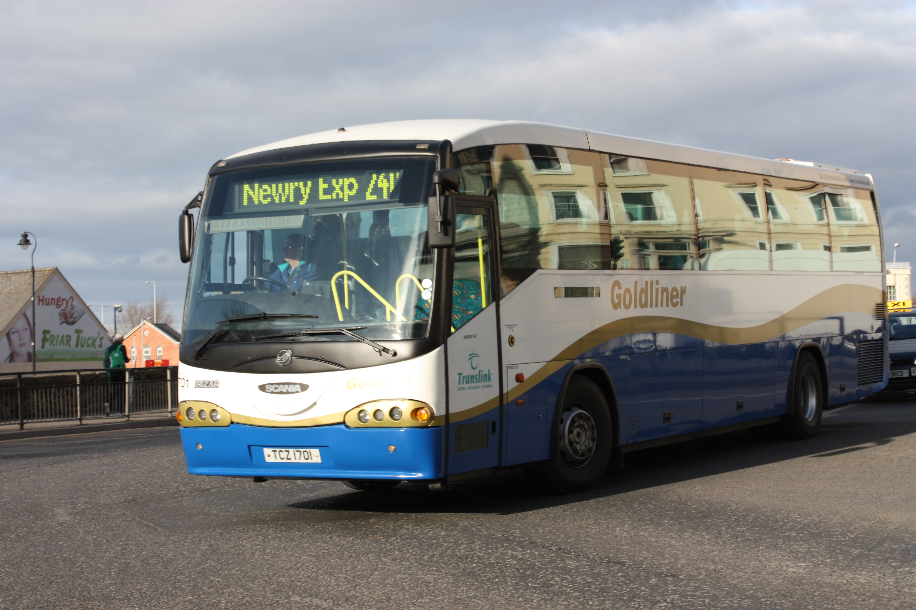

Also during circle time we will look at transport vehicles & how we move around & get to different destinations.

In addition during circle time children will have an input to make plans and they will also discuss what they have liked in the room and anything they would like to change. Their input and feedback will help staff shape plans to meet the children’s interests and needs.

THIS MONTH’S BIRTHDAY’S



Each month we may have a birthday celebration; we will create a birthday chart and sing “Happy Birthday”. Each child will be added to this chart as their birthday occurs throughout the year. If you wish you may send a cake/or healthy option to celebrate during break. (All Cakes must be nut free).

Happy birthday:
Frankie
Esme
😊
PHYSICAL ACTIVITIES

Physical activities will be continued to be promoted through both indoor and outdoor weekly plans.

We will also be spending lots more time in the garden and hopefully, it will continue to stay warm and we will be able to bring even more fun outdoors. Arts and crafts will be moved outside, along with other activities.

We will have lots of fun digging in the sand, splashing in the water, using our gardening tools, having lots of messy fun in our mud kitchen and exploring fairyland forest!!

Could you please ensure you have supplied a sun hat & sun cream otherwise we cannot take your child outside. ☺


ADDITIONAL INFORMATION

Can we ask that you please be extra cautious when driving around the car park area and always be aware of adults and children. We are sure you can appreciate that there are a lot of children within the nursery being collected at different times and it can be busy. Please always be attentive of this. Can we please remind you not to block the area where nursery vehicles are parked. This must be kept clear at all times so the vehicles can get in and out and we can safely off load the children. Thank you.

If you have any holidays planned over the next couple of months, could you please give us any dates as soon as possible as this really helps when working through staff holidays. Happy Holidays!!



Please note: Nursery will be closed on Wednesday 12th July & Thursday 13th July and will re-open again on Friday 14th July.

Thank you – Pre –school



