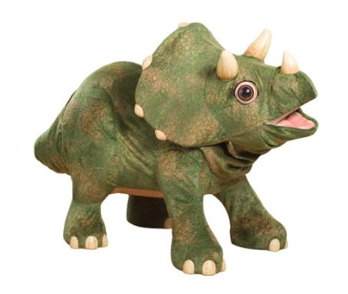

Jolly Rodgers Toddlers Newsletter May 2023

This month we will be looking at ‘THE WAY THE WORLD WAS – THE WAY WE WERE’

Our learning through play will continue to progress well throughout our monthly activities. The children will continue to build on new skills daily, please encourage these at home.
This month we will be looking at dinosaurs and the various kinds of dinosaur species, where they came from and how they developed and comparing to different types of animals now and where they live and introducing the zoo with all the animals. We will talk to the children about their different experiences at the zoo and about their favourite animals and dinosaurs. We will also be marking a moment in history with the ‘King’s Coronation’.

THIS MONTH’S SONG’S
- Down in the jungle
- 10 little dinosaurs
- An elephant walks like this and that
- 5 cheeky monkeys
- The animals at the zoo
- Itsy Bitsy monkey
- See you later alligator
- The Yellow giraffe
- The dinosaurs go marching
- Dino Ditty … and many more
THIS MONTHS COLOUR – BROWN & GREEN

Individual water trays will have bubbles with zoo animals.

Individual sand trays will contain dinosaur fossils and rocks.

Tuff tray will be filled with coronation pictures, coloured rice and pasta, changing to dinosaur templates and dinosaur ‘bones’ and we will add soil and shaving foam throughout the month.

THIS MONTHS ARTS (we will send home children’s work for you to display)

All art work will include gluing, sticking, colouring, painting and cutting relating to our theme - creating animals for our ‘zoo’ in the sensory areas, dinosaur pictures, zoo animal masks, hand print giraffes, footprint dinosaurs, paper plate animals, pictures of our favourite zoo animals and dinosaurs, dinosaur fossils & mark making, hand print dinosaur and animal & dinosaur footprint and much more.. We will also be enjoying coronation arts and crafts.

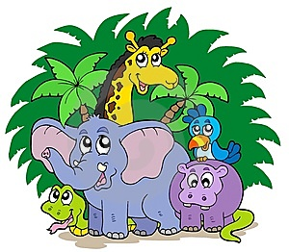

THIS MONTHS CIRCLE TIME

Within Toddlers we will use circle time to read stories & poems etc. to develop each child's love of books and language.

We will read books and learn our new rhymes. Our rhymes and stories will all be theme related and will include the following:
- Say hello to dinosaurs
- The short sighted giraffe
- At the zoo
- Dinosaurs love underpants
- The animal stomp
- Rumble in the jungle
- Giraffes can’t dance
- Little Rex
- Dinosaur Roar
- Elephant pants
- The lion who wanted to love
- Monkey Business

THIS MONTHS BIRTHDAY’S

Each month we may have a birthday celebration; we will create a birthday chart and sing ‘Happy Birthday’. Each child will be added to this chart as their birthday occurs throughout the year. If you wish you may send a cake/or healthy option to celebrate during break. (ALL CAKES MUST BE NUT FREE)

HAPPY BIRTHDAY:
Lucia
Talia

☺ ☺ ☺



PHYSICAL ACTIVITIES

Physical activities will be continued to be promoted through both indoor and outdoor weekly plans.

We will be outside everyday - please supply coats. The children will be introduced to a variety of games and outdoor equipment and hopefully Mr Sun will shine, and we will be able to have lots of fun in our mud kitchens and exploring in Fairyland Forest.

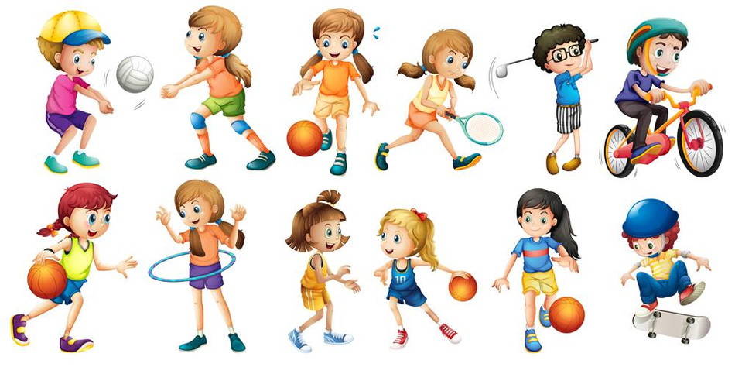
ADDITIONAL INFORMATION

Jolly Rodgers staff are here to discuss any aspect of your child with you at any time, either speak to one of us directly, via famly, phone or email and we will get back to you.

Can we ask that you please be extra cautious when driving around the car park area and always be aware of adults and children. We are sure you can appreciate that there are a lot of children within the nursery being collected at different times and it can be busy. Please always be attentive of this. Can we please remind you not to block the area where nursery vehicles are parked. This must be kept clear at all times so the vehicles can get in and out and we can safely off load the children. Whilst we realise it can be busy in car park with Jolly Pirates children arriving or being collected but can we please ask that you do be careful not to be blocking the drive or other cars as all parents do need to get in and out at these busy times. Thank you.

Please can you label all items of clothing as this will help prevent the wrong item of clothing going home with the wrong child. Thank you.

Can we please ask, if you know your child will not be attending nursery whether it be due to illness or holidays, that you let us know Thank you.

We are having a coronation tea party on Monday 8th May. We will be making coronation decorations and baking buns and shortbread for our tea party. If this is a day you are due to be in nursery please do come along dressed as a ‘King/Queen/Prince/Princess’ or wearing anything white, blue or red. 😊
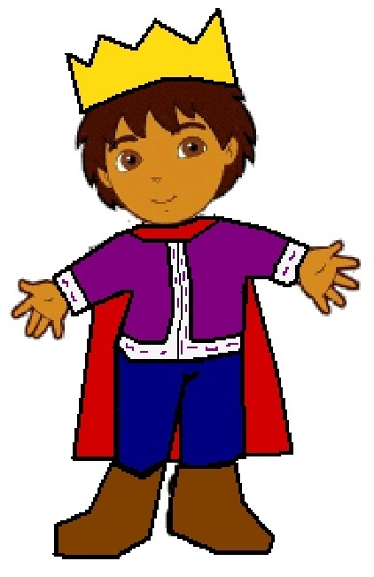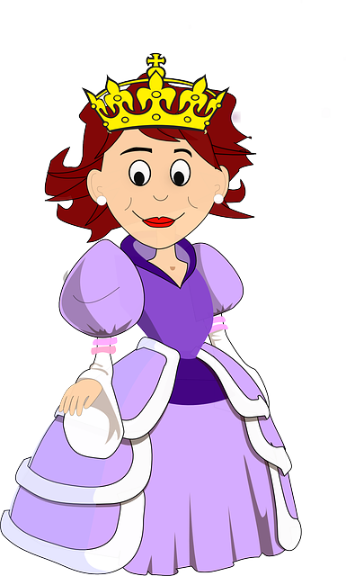

Thank you from all in Toddlers.

