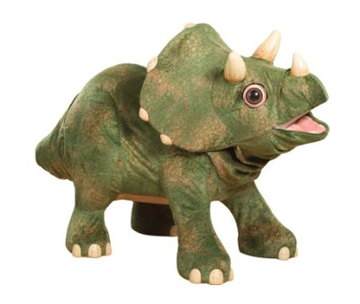

Jolly Rodgers Preschool Newsletter May 2023

This month we will be looking at ‘THE WAY THE WORLD WAS – THE WAY WE WERE’

Our learning through play will continue to progress well throughout our monthly activities. The children will continue to build on new skills daily, please encourage these at home.
This month we will be looking at dinosaurs and the various kinds of dinosaur species, where they came from, how they used to live and talking about being extinct and what this means, we also look at how they developed and compare to different types of animals now and where they live and introducing the zoo with all the animals. We will talk to the children about their different experiences at the zoo and about their favourite animals and dinosaurs. We will also be marking a moment in history with the ‘King’s Coronation’.

THIS MONTH’S SONG’S
- 10 little dinosaurs
- The dinosaurs go marching
- Sleeping Dino’s
- We are the dinosaurs
- Down in the Jungle
- 5 Cheeky monkey’s
- Dino Ditty … and many more
THIS MONTHS COLOUR - GREY

The water tray will contain fresh vegetables with cutters and plastic knives, encouraging fine motor skills and hand eye co-ordination & exploring.

The sand will contain dinosaurs. During the month this will change to wet sand encouraging mark making and moulding using bone moulds.

Tuff tray will be a dinosaur world.

THIS MONTHS ARTS (we will send home children’s work for you to display)

All art work will include gluing, sticking, colouring, painting and cutting relating to our monthly plans - e.g. paper plate lions, dinosaur pictures, hand printed Dino’s, making foot prints using paint and toy dinosaurs, observational drawings of dinosaurs and other animals. We will also be enjoying coronation arts and crafts.



Upper level of loft will be our medical area. Tuff tray will contain medical equipment, nurse’s outfits and extending our care for babies. Lower level will be sensory dinosaur land, including light box, sensory blocks, sorting coloured pompoms, dinosaur puppets.

THIS MONTHS CIRCLE TIME

Within the classroom we will use circle time to read stories & poems etc to develop each child's love of books and language.

We will read books and learn our new songs. Our rhymes and stories will all be theme related and will include the following:
- Dinosaurs love underpants
- The Dinosaur that lost his roar
- Harry’s bucket full of dinosaur’s
- How dinosaurs learn how to count
- Dinosayr
In addition during circle time children will have an input to make plans and they will also discuss what they have liked within the room and anything they would like to change. The children's input and feedback will help staff shape plans to meet the children's interests and needs.

THIS MONTHS BIRTHDAY’S

Each month we may have a birthday celebration; we will create a birthday chart and sing ‘Happy Birthday’. Each child will be added to this chart as their birthday occurs throughout the year. If you wish you may send a cake/or healthy option to celebrate during break. (ALL CAKES MUST BE NUT FREE)

HAPPY BIRTHDAY:
Emma
Katie
Leni
Ollie
Aine



PHYSICAL ACTIVITIES

Physical activities will be continued to be promoted through both indoor and outdoor weekly plans. We will be outside everyday - please supply coats. The children will be introduced to a variety of games and outdoor equipment and hopefully Mr Sun will shine and we will be able to have lots of fun in our mud kitchens and exploring in Fairyland Forest.

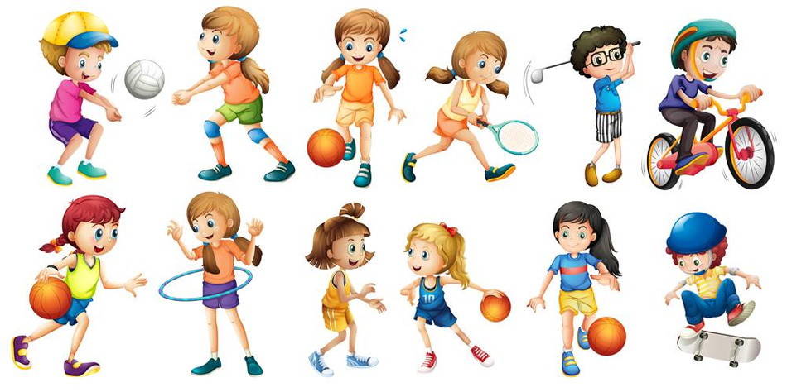

ADDITIONAL INFORMATION

Jolly Rodgers staff are here to discuss any aspect of your child with you at anytime, either speak to one of us directly, via famly, phone or email and we will get back to you.

Can we ask that you please be extra cautious when driving around the car park area and always be aware of adults and children. We are sure you can appreciate that there are a lot of children within the nursery being collected at different times and it can be busy. Please always be attentive of this. Can we please remind you not to block the area where nursery vehicles are parked. This must be kept clear at all times so the vehicles can get in and out and we can safely off load the children. Whilst we realise it can be busy in car park with Jolly Pirates children arriving or being collected but can we please ask that you do be careful not to be blocking the drive or other cars as all parents do need to get in and out at these busy times. Thank you.

Please can you label all items of clothing as this will help prevent the wrong item of clothing going home with the wrong child. Thank you.

Can we please ask, if you know your child will not be attending nursery whether it be due to illness or holidays, that you let us know. Thank you.

We would like to welcome Jenny to Jolly Rodgers Team. Jenny will be collecting children from school along with Deirdre and Albert. Please do say hello if you see her out and about. 😊
We are having a coronation tea party on Monday 8th May. We will be making coronation decorations and baking buns and shortbread for our tea party. If this is a day you are due to be in nursery please do come along dressed as a ‘King/Queen/Prince/Princess’ or wearing anything white, blue or red. 😊
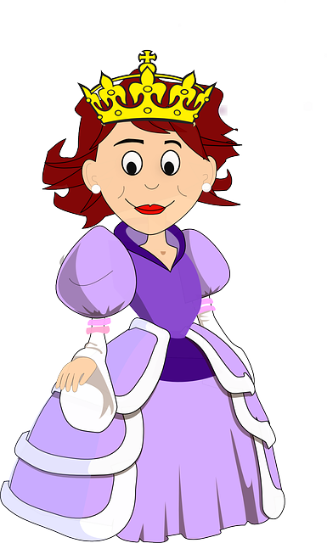

Thank you from all in Pre-school.

