JOLLY RODGERS
OUT OF SCHOOLS NEWSLETTER
December 2022

December plans
December we will be looking at ‘What do we celebrate’. All the children will get a chance to input their ideas during the month for art and craft ideas to outdoor activities. Chip has arrived back with us for a month of fun and frolics!!
There will be planned activities during the weeks. This will include:
- Christmas tree decorating, making Christmas placemats, Christmas cards, Christmas decorations
- Decorating our outdoor area
- Hot chocolate reindeers
- Look at project related clips on YouTube
- Santa letter and toy lists
- Various cooking activities to be completed. – shortbread and snowballs.
Plenty of activities to keep us going this month.
<Birthdays this month>
- Eva
- Ryan
- James
- Emily
- Amy
- Tabitha
- Rhea
😊 Lots of celebrating this month!! 😊
Additional Information:
Can we ask that you please be extra cautious when driving around the car park area and always be aware of adults and children. We are sure you can appreciate that there are a lot of children within the nursery being collected at different times and it can be busy. Please always be attentive of this. Can we please remind you not to block the area where nursery vehicles are parked. This MUST be kept clear at all times so the vehicles can get in and out and we can safely off load the children. Thank you.

Could you please inform us of any changes to collection times for schools during this festive season. As you can appreciate, we do need as much notice as possible to be able to organise these different times. Thank you.

CHILDREN IN NEED
Just a little thank you for your support on our PJ Day. Total amount raised was £450.00!!! THANK YOU!!
Santa Claus is coming to Jolly Rodgers! 😊 We will be transforming our cabin into a magical Christmas Grotto in preparation for our visit from Santa himself. Santa will deliver presents to the children. Don’t worry if your child is absent on the day as Santa will be leaving a gift for them to take home on a day when they are in nursery. Jingle all the way!!

We will be having lots of Christmas fun throughout the month of December with lots of music, treats and games! ☺

We have always been very appreciative of your kindness and generosity at Christmas time and even more so throughout this year, but we ask that you would consider making a voluntary contribution to charity or a food bank as an alternative to providing Christmas gifts.

We are genuinely appreciative of your thoughtfulness but, really to us, our thanks is having the pleasure of spending time with all your little treasures and having the privilege of watching each of them grow in independence, personality and ‘wisdom’ ☺ ☺

Staff will be getting into the festivities by wearing Christmas Jumpers every Friday. We can’t wait to see all your lovely jumpers/dresses/shirts/headbands etc……!! 😊 😊
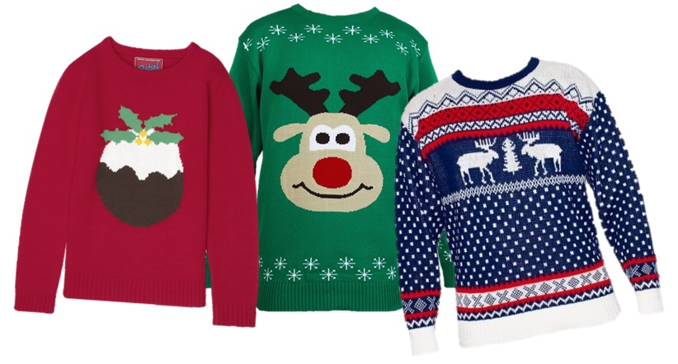
CHRISTMAS EVE – EVE (FRIDAY 23rd)
Come along to nursery in your Christmas PJ’s. Everyone will be full of Christmas spirit and fun, so we are going to have a very chilling PJ Day!!

CHRISTMAS CLOSURE
Nursery will be closed from MONDAY 26th DECEMBER and will re-open again on TUESDAY 3rd JANUARY 2023.

And finally: May we take this opportunity to thank you all once again for your continual support throughout this year and to wish you all a very merry Christmas and a happy and prosperous New Year.

Thank you.
Out of School staff



