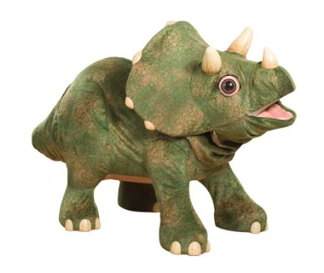

Jolly Rodgers Wobblies Newsletter May 2022

This month we will be looking at ‘THE WAY THE WORLD WAS – THE WAY WE WERE’

Our learning through play will continue to progress well throughout our monthly activities. The children will continue to build on new skills daily, please encourage these at home. This month we will be looking at dinosaurs and the various kinds of dinosaur species. We will also be exploring the zoo and various animals which can be found at the zoo.
THIS MONTH’S SONG’S –
- An elephant walks like this and that
- 5 cheeky monkeys
- The animals at the zoo
- Itsy Bitsy monkey
- See you later alligator
- The Yellow giraffe
- The dinosaurs go marching
- Dino Ditty … and many more
- Daddy’s taking us to the zoo
Each month we encourage the children with counting, counting toys, books etc. This month we will be counting different dinosaurs and zoo animals.
THIS MONTHS COLOUR – ORANGE & GREY

Individual water trays will contain orange glitter and zoo animals.

Individual sand trays will contain dinosaurs and animals and animal masks.

MESSY PLAY / SENSORY DEVELOPMENT

We will be getting messy in spaghetti, orange jelly and shaving foam, Rice & pasta. Dough will have dinosaur fossils for printing and mark making.

Tuff tray – ‘Going on a dinosaur hunt’. We will be digging through the swamps and soil on our hunt for dinosaur fossils. We will also be creating our own zoo with lots of different zoo animals. We will be hearing all the different sounds the animals make and having some fun in the water with all the sea animals e.r penguins etc.

THIS MONTHS ARTS (we will send home children’s work for you to display)

All art work will include gluing, sticking, colouring, painting, junk art and cutting relating to our theme - creating animal handprints, dinosaur pictures, dinosaur footprints, zoo pictures and animal masks and lots more.



THIS MONTHS CIRCLE TIME

Within Wobblies we will use circle time to read stories & poems etc. to develop each child's love of books and language.

We will read books and learn our new rhymes. Our rhymes and stories will all be theme related and will include the following:
- Noisy dinosaur
- Cheeky Monkey
- Stop monkeying around
- Monkey tricks
- The animal bop won’t stop



THIS MONTHS BIRTHDAY’S

Each month we may have a birthday celebration; we will create a birthday chart and sing ‘Happy Birthday’. Each child will be added to this chart as their birthday occurs throughout the year. If you wish you may send a cake/or healthy option to celebrate during break. (ALL CAKES MUST BE NUT FREE)

HAPPY 2nd BIRTHDAY
Lucia



PHYSICAL ACTIVITIES

We will be spending lots of time in the garden and will have lots of fun, playing with balls & gardening tools, having lots of messy fun in our mud kitchen and exploring in Fairy land Forest. Hopefully Mr Sun will shine so we can go for lots of walks. Please ensure your child has a coat with them each day.



ADDITIONAL INFORMATION

Jolly Rodgers staff are here to discuss any aspect of your child with you at anytime, either speak to one of us directly, via seesaw, phone or email and we will get back to you.

Can we ask that you please be extra cautious when driving around the car park area and always be aware of adults and children. We are sure you can appreciate that there are a lot of children within the nursery being collected at different times and it can be busy. Please always be attentive of this. Can we please remind you not to block the area where nursery vehicles are parked. This must be kept clear at all times so the vehicles can get in and out and we can safely off load the children. Whilst we realise it can be busy in car park with Jolly Pirates children arriving or being collected but can we please ask that you do be careful not to be blocking the drive or other cars as all parents do need to get in and out at these busy times. Thank you.

We would like to welcome Chelsea to Jolly Rodgers Team. Please do say hello to her if she greets you at the door. 😊

We do hope you all enjoyed a lovely Bank Holiday weekend. Just a little reminder that the nursery will be closed on Friday 3rd June for the Jubilee Bank Holiday. Thank you.

Can we please ask, if you know your child will not be attending nursery whether it be due to illness or holidays, that you let us know Thank you.

Thank you all for your patience whilst all the work is being carried out around the nursery. We really do appreciate this.

Thank you from all in Wobblies.

