
JOLLY RODGERS
OUT OF SCHOOLS NEWSLETTTER
January 2022

This month we will be looking at ‘What do we need?’ This will include food and healthy lifestyles.
We will be looking at and discussing lifestyles and how maintain a healthy lifestyle. The children will design their own healthy routine to carry out in out of school or at home e.g., eat fruit instead of chocolate, water instead of juice, and exercise instead of technology.
What foods can we eat to help keep us fit. The children will look at various foods healthy and unhealthy and compare the difference in the products.

How we keep ourselves clean – e.g washing, clean clothes, brushing our teeth etc.

- Outside play.
We will be outside whatever the weather.. to explore our surrounding. During outdoor play children will be making dens, going on nature hunts, playing in the mud kitchen, exploring fairyland forest, and helping maintain the garden areas.
Why does this matter? Quite simply, outdoor play is good for children and even more so at the present time!
The benefits of outdoor play are well documented, and include:
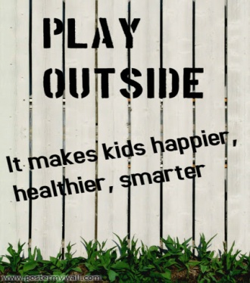
- increasing physical activity
- increasing the body's vitamin D levels
- reducing anxiety and improving mood
- improving concentration and focus
- enhancing imaginative and creative play
- promoting problem solving and leadership skills
- developing stronger immune systems

Less time spent playing outdoors is linked to:
- obesity
- type II diabetes and high blood pressure
- high cholesterol
- anxiety disorders and depression
- attention deficit disorder
There has never been a more important time for parents and educators to make outdoor play a priority for the children in their lives. It is one of the best things that we can do for their health, education, and well-being.


<Birthdays this month>
Samuelle
Oscar
Hazel

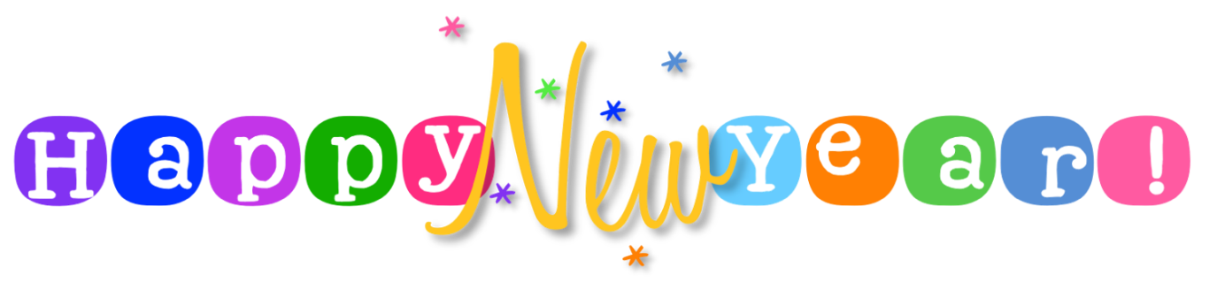
We would just like to take this opportunity to thank you all for the gifts, gift cards, donations to charities, food bank donations, cards, and emails. We are overwhelmed with your generosity. These really have meant so much to us all. THANK YOU!! THANK YOU!!
We do hope you all managed to have a safe and happy Christmas and New Year and now we look forward to a hopefully better year ahead 2022!!

Driveway – Can we please encourage you to drive carefully when entering and exiting the car park? Always be on the lookout for adults and children as they arrive and leave the nursery and please do not park where nursery vehicles need to be getting in and out.
Can we please ask, if you know your child will not be attending school whether it be due to illness or holidays and will therefore not need a collection that you let us know. Thank you.

Thank you.
Out of School staff

